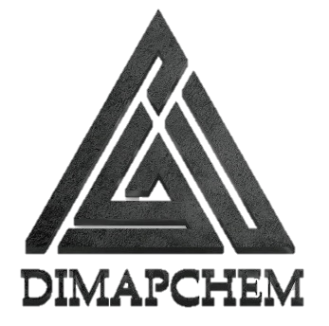
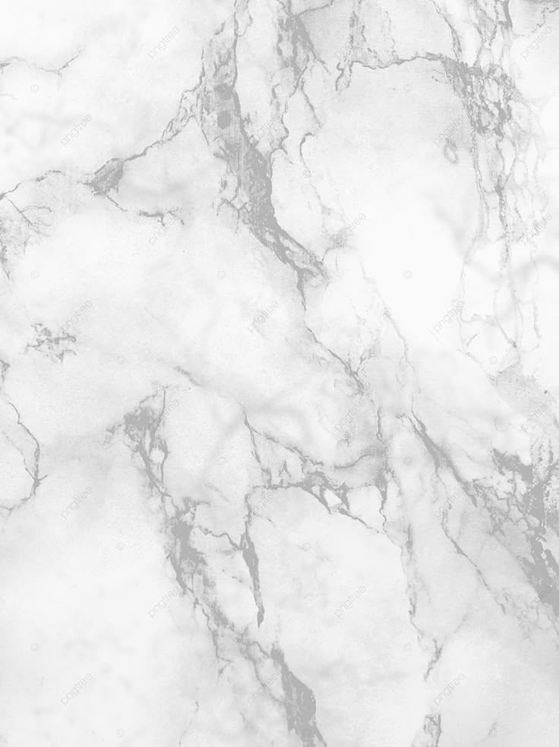
DIMAPCHEM PRIMER SF WET
WET CURE PRIMER

BENEFITS
- Exceptionally good bond.
- Ensured good bond venin damp conditional.
- Good mechanical strength.
- Simple to apply.
- High levels of adhesion.
- Can be used for prime before coating and screed.
- To penetrate porosity.

PRODUCT
DIMAPCHEMPRIMER-SF PH has developed to give excellent of screed and mortar where substrate is wet and where epoxy treatment makes impossible. DIMAPCHEMPRIMER-SF PH is a two pack epoxy resin based primer to ensure excellent bond of coating, screed on the substrate.

USES
To protect concrete floors, enhanced resistance to oil, grease, water penetration, dust, abrasion and chemical attack.

SHELFLIFE&STORAGE
DIMAPCHEMPRIMER-SF PH will have a shelf life of 12 months in unopened containers when kept in dry conditions at a temperature between 5ºC to 45ºC. Storage at higher temperature or high humidity may reduce shelf life.
Visit us on : http://www.dimapchem.com/
EMAIL: Info@dimapchem.com
ALL PRODUCTS EXAMINED BY GFC LAB-ITALY

PACKING&COVERAGE
U.S. GALLON U.S. PAIL .

QUALITYASSURANCE
DIMAPCHEM SARL manufactures entire range of construction chemicals ,wood coating ,decorative paint ,and water proof system .

TECHNICALSERVICES
While new advances and changes will take place but one thing will never change is quality and meeting special needs of our customers. Our technical personnel & experts are available to provide additional information and technical assistance. We are eager to work with you in development of new product and resolve your problem.

Application Fields
DIMAPCHEMPRIMER-SF PH Is a ideal solution for wet slabs to be applied by epoxy and it is a good solution where heavy traffic and load will be a main issue for any needed application like ware houses printing shops metal mechanical industry ,public parking ,malls ,chemical plant, sports marine clubs, steel coating for heavy weathering conditions and marine condition and others …

DIMAPCHEM-TMPRIMER SF
Visit us on : http://www.dimapchem.com/
EMAIL: Info@dimapchem.com
ALL PRODUCTS EXAMINED BY GFC LAB-ITALY
Technical Summary For DIMAPCHEMPRIMER- SF PH
Chemistry
Color | TANSPARENT BROWN AFTER HARDENER MIX
gloss level | Semi Gloss /
Volume Solids | 98% ± 2%
typical thickness | 98 ± 2%Micron dry Equivalent to 100Microns  Wet.
theoretical coverage | ~1M2 / Liter at 1000Microns
practical coverage | Allow Appropriate Loss Factor

Flash Point |  | 27 ˚C
Specific Gravity |  | CLEAR 1.08 Kg/l ± 2%/
VISCOSITY |  | 120KU/25°C ± 3%
RECOMMENDED THICKNESS FOR | FLOORING | USE :250 /300 MICRONS
Voc |  | close to minimum possible
Application Method
common application fields |  | General Steel /FLOORING
HARDENER |  | SF –PH 50%BY WEIGHT
Application methods |  | Airless/tip: .028''/.030'', pressure at tip not less than 200 bar Conventional / (pressure pot): 1.4mm Nozzle / 4 Bars  Brush  Roller
Number of Coats
Recoating interval at 25˚C |  | 24 Hours / Max 7 Days
Thinning |  | NONE
cleaner |  | DIMAPCHEMCleaning Thinner
preparation of substrate |  | For Iron SA 2.5
Dry Time |  | 1 Hour Touch Dry, 3 - 5 Hours Hard
Time to clean application equipment |  | Immediately after use.
Packaging |  | 1 Quart, U.S. Gallon &U.S. Pail
storage |  | Between 5˚C and 45°C Degrees
Shelve life storage |  | 12 Month
Shipping weight not including pallets and boxes |  | us gallon/---kg imp gallon/---kg pail of  5usg /---kg pail 25litrs kg
recommended systems and compatibility Top Coat DIMAPCHEMEPE, MU,SF Top Coat DIMAPCHEMPU - UD, PU-D

Visit us on : http://www.dimapchem.com/
EMAIL: Info@dimapchem.com
ALL PRODUCTS EXAMINED BY GFC LAB-ITALY

